About the BiCom System

Description

This Project is an BiCom System,and is designed to remotely know the statues of your automobiles, BiCom System operates by broadcasting radio waves on a particular frequency Bidirectionally.

Identifying features

It shall print window status of the car when Button is pressed ONCE

It shall print alarm status the car when Button is pressed TWICE

It shall print car battery info when the Button is pressed THREE times

It shall print door status of the car when the Button is pressed FOUR times

5W's & 1H

WHAT

BiCom System for Car is a system that uses a 40-bit rolling code that creates an encryption in between the key and car (transmitter and receiver).

WHO

Any person who is having car that is able to use this type of technology.

WHERE

Inside and Outside car

At particular range for instance 50 to 60 feet far from the vehicle.

WHEN

When we need to lock, unlock doors, and identify car

when we need to check the status of the door, alarm , car battery and window.

WHY

Better Security - Traditional keys are easy to lose, can be copied easily, and are simply outdated when it comes to modern security locks.

BiCom System systems require every authorized user to have a unique credential that provides them access to the building.

HOW

The controller chip in any modern controller uses something called a hopping code or a rolling code to provide security.

For example, it describes a system that uses a 40-bit rolling code. Forty bits provide 240 (about 1 trillion) possible codes.

Requirements

High Level Requirements

| ID | High Level Requirements |
| --- | --- |
| HLR 1 | It shall print THE STATUS OF WINDOW IN CAR |
| HLR 2 | It shall print THE STATUS OF ALARM IN CAR |
| HLR 3 | It shall print THE STATUS OF BATTERY IN CAR |
| HLR 4 | It shall print THE STATUS OF DOOR IN CAR |

Low Level Requirements

| ID | Description |
| --- | --- |
| LLR_01 | If the User presses the Blue Button ONE TIME, All Led should be turned ON |
| LLR_02 | System shall print message "Window Status" |
| LLR_03 | If the User presses the Blue Button TWO TIMES, All Led should be turned OFF |
| LLR_04 | System shall print message "Alarm Status" |
| LLR_05 | If the User presses the Blue Button THREE TIMES, All Led should rotate in clockwise direction |
| LLR_06 | System shall print message "Car Battery Status" |
| LLR_07 | If the User presses the Blue Button FOUR TIMES, All Led should rotate in anti-clockwise direction |
| LLR_08 | System shall print message "Door Status" |

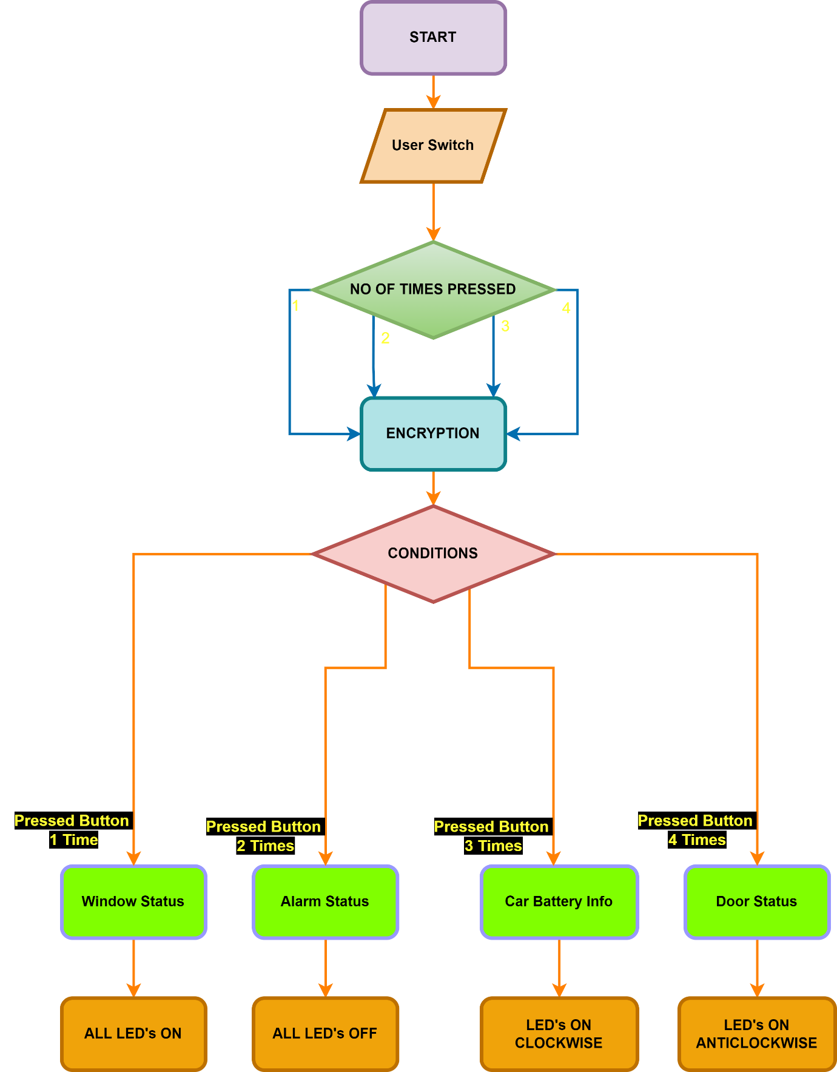

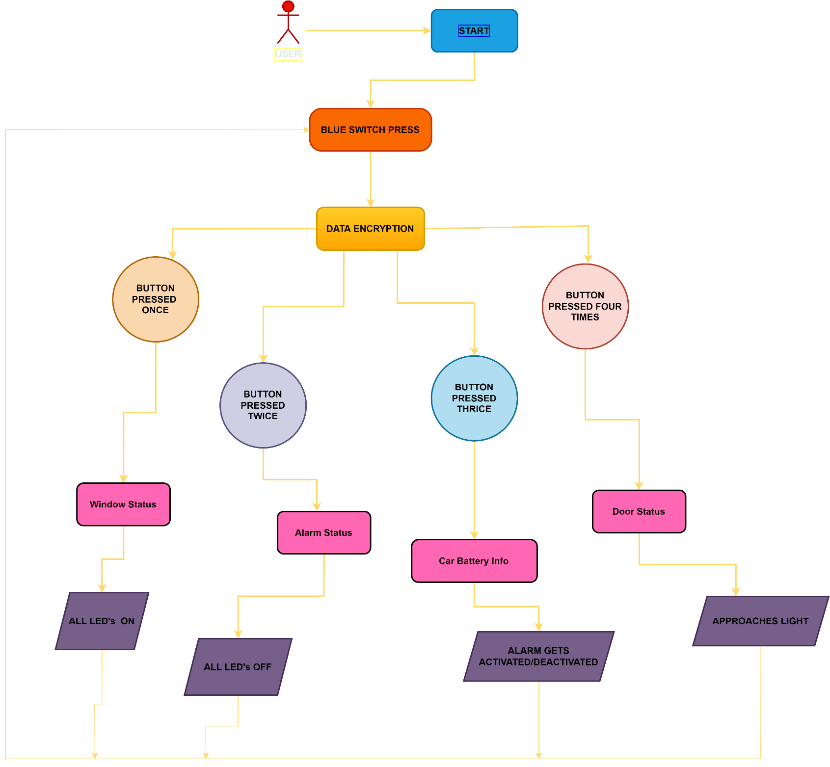

# Test Plan And Output

# 1.1 HIGH LEVEL

| **Test ID** | **Description** | **Input** | **Expected output** | **Actual Output** |
| --- | --- | --- | --- | --- |
| HL_TP01 | Print The Status Of Window | When User press the Button once | Should Print The Status Of Window | The Status Of Window is |
| HL_TP02 | Print The Status Of Alaram | When User press the Button Twice | Should Print The Status Of Alaram | The Status Of Alaram is |
| HL_TP03 | Print The Status Of Car Battery | When User press the button Thrice | Should Print The Status Of Car Battery | The Status Of Car Battery is |
| HL_TP04 | Print The Status Of Door | When User press the button Four Times | Should Print The Status Of Door | The Status Of Door is |

# 1.2 LOW LEVEL

| **Test ID (for LED)** | **Description** | **Input** | **Expected output** | **Actual Output** | **passed/not** |
| --- | --- | --- | --- | --- | --- |
| LL_TP01 | Verify the Window Status | User should press the Button once | LED's Should be ON | LED's are ON |  |
| LL_TP02 | Verify the Alaram Status | User should press the Button Twice | LED's Should be OFF | LED's are OFF |  |
| LL_TP03 | Verify the Car Battery Status | User should press the Button Thrice | LED ON Should be in Clockwise Rotation | LED's ON are in Clockwise Rotation |  |
| LL_TP04 | Verify the approach Door Status | User should press the Four Times | LED ON Should be in Anticlockwise Rotation | LED's ON are in Anticlockwise Rotation |  |